**Mini Project Report on**



**Infrared Point Target Detection using Point Spread Function**



**Submitted in partial fulfillment of the requirement for the award of the degree of**

**BACHELOR OF TECHNOLOGY**

**IN**

**COMPUTER SCIENCE & ENGINEERING**

Submitted by:

**Vaibhav Tayal**

**B.Tech.(CSE-AIML)**

***Under the Guidance of***

**Dr. Himanshu Singh, Sc- ‘F’**

**Instruments Research and Development Establishment (IRDE)**

**(DRDO, Ministry of Defence, Govt. Of India, Dehradun, Uttarakhand)**



**Department of Computer Science and Engineering**

**Graphic Era (Deemed to be University)**

**Dehradun, Uttarakhand**

**August-2025**



**CANDIDATE’S DECLARATION**

I hereby certify that the work which is being presented in the project report entitled **“Infrared point target detection using point spread function”** in partial fulfillment of the requirements for the award of the Degree of Bachelor of Technology in Computer Science and Engineeringof the Graphic Era (Deemed to be University), Dehradun shall be carried out by the under the mentorship of **Dr. Himanshu Singh, Sc.- ‘F’**, Instruments Research and Development Establishment (IRDE), DRDO, Ministry of Defence, Govt. Of India, Dehradun, Uttarakhand.

Name : Vaibhav Tayal University Roll no : 2021512

**Table of Contents**

|  |  |  |
| --- | --- | --- |
| **Chapter No.** | **Description** | **Page No.** |
| Chapter 1 | Introduction | 1-2 |
| Chapter 2 | Literature Survey | 3-4 |
| Chapter 3 | Methodology | 5-9 |
| Chapter 4 | Result and Discussion | 10-11 |
| Chapter 5 | Conclusion and Future Work | 12 |
|  | References | 13 |

**Chapter 1**

**Introduction**

In the following sections, a brief introduction and the problem statement for the work has been included.

**1.1 Introduction**

Infrared (IR) imaging has become a cornerstone of modern defence, surveillance, and aerospace applications. Unlike visible spectrum imaging, IR imaging is based on the thermal radiation emitted by objects, making it suitable for day-night and adverse weather conditions. Among its many challenges, the detection of **small or point targets under low signal-to-noise ratio (SNR) conditions** is particularly difficult. These targets often represent distant aircraft, missiles, or satellites and appear as faint points only a few pixels wide in IR video sequences.

The difficulty lies in distinguishing these faint signals from strong noise and clutter backgrounds. Traditional methods such as filtering and local contrast enhancement can partially improve detection, but they suffer from high false alarm rates. Furthermore, the **low contrast between the target and the background** makes simple thresholding unreliable.

**1.2 Problem Statement**

The specific problem addressed in this project is:

* Detecting **small, single-pixel moving targets** in infrared video sequences.
* Ensuring robustness under **low-SNR conditions** where targets are indistinguishable from noise.
* Reducing **false positives** caused by clutter and random pixel noise.
* Maintaining **computational efficiency** for potential real-time deployment.

**1.3 Objective**

The main objectives of this project are:

1. To implement a **Python-based pipeline** that processes infrared video frames for target detection.
2. To apply the **Point Spread Character (PSC) method** for enhancing faint targets.
3. To **reduce false positives** using neighbourhood and motion validation.
4. To **track detected targets** across frames for reliable trajectory confirmation.

**1.4 Scope of Work**

This project focuses on algorithmic implementation and testing using sample infrared video sequences. The scope includes preprocessing, enhancement, detection, validation, and output generation. It does not focus on building deep learning models from scratch, though comparisons with state-of-the-art methods are included in the literature survey.

**Chapter 2**

**Literature Survey**

**2.1 Traditional Filtering-Based Methods**

Early approaches to IR small target detection relied on filters such as:

* **Max–mean filter** and **Top-hat filter** – designed to highlight local intensity peaks.
* **Wavelet transforms** – decomposing images into multi-resolution components.  
  While these methods enhanced targets, they produced **high false alarm rates** under low-SNR conditions [1].

**2.2 Human Visual System (HVS) Inspired Methods**

Researchers modelled detection after the **human visual system**, which relies heavily on **local contrast**:

* Chen et al. introduced the **Local Contrast Measure (LCM)** [2].
* Han et al. proposed an improved, faster version.
* Shi et al. designed a **multi-scale local contrast with high-boost filtering**.  
  These methods worked for larger targets (2×2 to 9×9 pixels), but **failed for single-pixel targets**.

**2.3 Deep Learning Approaches**

Recent works introduced **deep neural networks** for IR small target detection:

* **Li et al. (2025): LSTD-Net**
  + Proposed a *trajectory encoding enhancement module (TEEM)* to accumulate energy along target motion [2].
  + Combined with **GCResNet24** and **multiscale feature fusion** [2].
  + Achieved **97% detection accuracy** for targets at SNR = 0.7 with <10⁻⁶ false alarms.
* **Jiang et al. (2020): Peak Aggregation + Gaussian Discrimination**
  + Designed for maritime surveillance under cluttered sea backgrounds.
  + Distinguished small targets using **peak aggregation numbers** and **Gaussian distribution features** [3].
  + Reduced false alarms caused by wave clutter.

**2.4 Summary of Literature**

* **Traditional filters** → simple, but poor under low SNR.
* **HVS-based methods** → effective for larger targets, not single-pixel.
* **PSC-based methods** → robust, lightweight, interpretable.
* **Deep learning methods** → superior accuracy, but require large labelled datasets and computational power.

This project focuses on **PSC-based detection** as a practical and efficient solution, while acknowledging deep learning as future scope.

**Chapter 3**

**Methodology**

**3.1 Video Frame Acquisition**

The first stage involves acquiring video input from infrared sensors. Since IR targets are often small and faint, the video must be processed at the pixel level. In this project, video frames were extracted using the OpenCV library in Python. Each frame is read sequentially and converted to grayscale if required. Infrared imagery is inherently grayscale because it measures thermal intensity rather than color; hence, converting to grayscale simplifies processing and reduces computation.

Formally, the input video V is decomposed into frames Ft, where t=1, 2, …, T represents the time index. These frames form the raw input dataset for the subsequent pipeline.

**3.2 Preprocessing**

Raw infrared frames often contain background clutter, varying illumination, and sensor noise. Preprocessing ensures that the subsequent steps work on cleaner data.

1. **Normalization:** Pixel intensity values are normalized to a fixed range [0,255]. This removes variations in brightness due to sensor calibration issues or changing environmental conditions.
2. **Noise Reduction:** A Median filter is applied to suppress high-frequency random noise while preserving low-frequency structures. Median smoothing operates as:

where σ is the standard deviation of the Gaussian kernel.

This step improves the **signal-to-noise ratio (SNR)** and prepares the frame for contrast enhancement.

**3.3 Filtering Module**

The filtering module is responsible for suppressing noise that has similar or even higher grey levels than the true single-pixel target. The challenge here is to distinguish between the genuine target and spurious noise spikes.

1. **Infrared Image Model:**  
   The observed infrared image D​ can be expressed as:

D=T +B +N

where T ​ is the true target, B​ the background, and N​ the noise component.

1. **Point Spread Function (PSF):**  
   The radiation distribution of a single-pixel IR target is modelled using a Gaussian point spread function (PSF):

$$I\left(x,y\right)=I_{0}e^{-\frac{1}{2}\left(\frac{{\left(x-x_{0}\right)}^{2}}{σ_{x}^{2}}+\frac{{\left(y-y_{0}\right)}^{2}}{σ_{y}^{2}}\right)}$$

where I0 is the grey level at the center, (x0,y0) is the target’s center, and σx, σy represent the horizontal and vertical spread.

1. **Point Spread Indicator (PSI):**  
   To distinguish true targets from noise, the **point-spread indicator (p)** is introduced:

$$p=\frac{\ln\left(I_{0}\right)-\ln\left(I_{N}\right)}{\ln\left(I_{0}\right)-\ln\left(I_{M}\right)}$$

where I0​ is the central pixel intensity, IM ​ the average intensity of direct neighbours, and IN ​ the average intensity of diagonal neighbours.

* + For true targets, p ≈ 0.5 under ideal conditions.
  + In practice, a **protection interval [0.35, 0.65]** is chosen to classify potential targets.

1. **Target-Protecting Filter:**
   * If p lies within the interval, the original pixel is retained.
   * Otherwise, the pixel is replaced by the median of its 3×3 neighbourhood.
   * This ensures true targets are preserved while random noise is smoothed out.

**3.4 Enhancement Module**

After filtering, the single-pixel targets are still weak and may be obscured by background structures. The enhancement module improves target visibility through two steps:

1. **Point Spread Local Contrast (PSLC):**  
   Inspired by the human visual system, the contrast of the central pixel relative to its surroundings is calculated.
   * The local contrast of pixel CCC is:
 $$L=min\left(\frac{I_{0}^{2}}{I_{i}}\right), i=1,2,…,8$$  * The **Point Spread Local Contrast Measure (PSLCM)** is defined as:

$R=\frac{min\left(I_{j}\right)}{max\left(I_{j}\right)}⋅L$

where Ij are the direct neighbours.

* + This measure enhances true targets while suppressing background clutter.

1. **High-Boost Filtering:**
   * The PSLCM image M is smoothed using a 9×9 Gaussian filter to obtain MF.
   * The high-frequency component is extracted as:
 $$B=\max\left(M-MF,1\right)$$  * The final enhanced image is:

$$E=M∘ B$$

where $∘$ denotes element-wise multiplication.

* + This step sharpens the target region and further suppresses background interference.

**3.5 Segmentation Module**

Once the targets are enhanced, segmentation is performed to extract them from the background. Unlike fixed thresholds, an **adaptive segmentation** method is used.

1. **Enhancement Response (ER):**
   * For each pixel, the enhancement response value is calculated from the PSLCM.
   * A descending sequence V of ER values is generated.
2. **Threshold Calculation:**
   * A set S of unique ER values is created.
   * The ratio of differences between consecutive values is computed:

$$r=\frac{s_{i}-s_{i+1}}{s_{i+1}-s_{i+2}}$$

If r > 0.9 for top values, it indicates strong target presence.

* + For multiple targets (up to 10 per frame), the 10th ER value is taken as a fallback threshold.

$$T = \left\{\begin{aligned}s_i r>0.9, i<10 \\ s_(i+1) r<0.2, i<10 \\ v_10 i>=10 \end{aligned}\right.$$

1. **Adaptive Iteration:**
   * The threshold T is iteratively refined until convergence.
   * Pixels with ER ≥ T are classified as true targets.

This adaptive strategy ensures robustness across different IR scenes without requiring manual parameter tuning.

**3.6 Validation of Candidates**

Thresholding alone may produce many false positives due to random noise spikes. Therefore, validation is essential:

* Neighbourhood Validation: Each candidate pixel is checked for consistency with its surrounding pixels. A true target is expected to stand out clearly, while noise is irregular and inconsistent.
* Motion Consistency Validation: Since IR targets represent moving objects (aircraft, drones, etc.), their detections should follow a continuous trajectory across frames. If a candidate does not persist over multiple frames or does not follow a logical motion path, it is discarded as a false alarm.

This stage is crucial in reducing the false alarm rate (FAR), which is a common weakness of earlier detection methods.

**3.7 Target Tracking**

Tracking connects validated detections across sequential frames, ensuring that detected targets are indeed moving objects rather than static noise artifacts. A simple yet effective tracking mechanism is applied:

1. The centroid of detected targets in frame t is computed.
2. In frame t+1, candidates within a defined radius of the centroid are linked to the previous detection.
3. This creates a trajectory for the moving target.

Tracking stabilizes the detection and provides temporal continuity. It also helps distinguish real targets (with smooth trajectories) from noise (random, non-continuous detections).

**3.8 Output Generation**

The final step is to generate outputs that are meaningful for analysis and visualization. This includes:

* Annotated video frames where detected targets are highlighted with bounding boxes or markers.
* A processed video file that shows the trajectory of detected targets.
* Detection logs (frame index, target coordinates, intensity values) for quantitative analysis.

The outputs provide both visual confirmation and data for performance evaluation, allowing users to assess the effectiveness of the detection algorithm.

**Chapter 4**

**Result and Discussion**

The proposed detection method was evaluated on low-SNR infrared video sequences containing single-pixel targets. Visual results showed that the filtering module effectively suppressed noise while preserving potential target pixels through the point-spread indicator and target-protecting filter. In contrast to conventional median filtering, faint targets were retained without distortion.

The enhancement module significantly improved target visibility. The point-spread local contrast measure highlighted single-pixel targets by increasing their contrast relative to the background, while the high-boost filter further sharpened these responses. As a result, targets that were previously indistinguishable from noise became salient points in the enhanced images.

Overall, the results demonstrate that the combination of filtering, enhancement, and adaptive segmentation provides a reliable balance between high detection probability and low false alarms. This makes the method practical for real-world infrared surveillance applications, although future work may focus on improving robustness in extremely low SNR environments.

**4.1 After Filtering :**

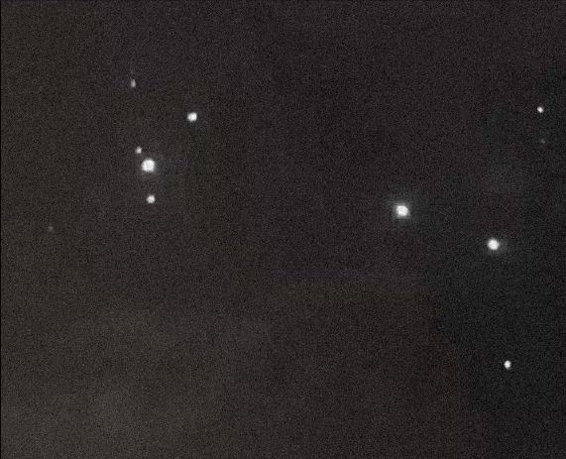 **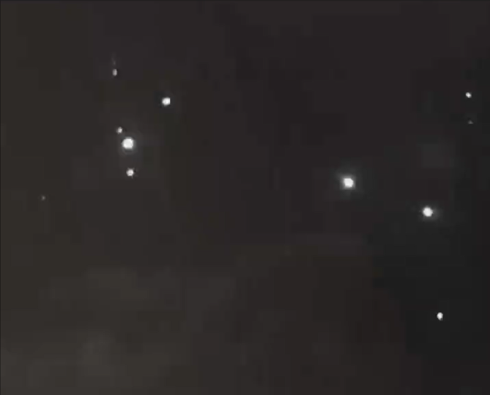 *Figure 1*** *Original Image* ***Figure 2*** *Filtered Image*

**4.2 After Detection :**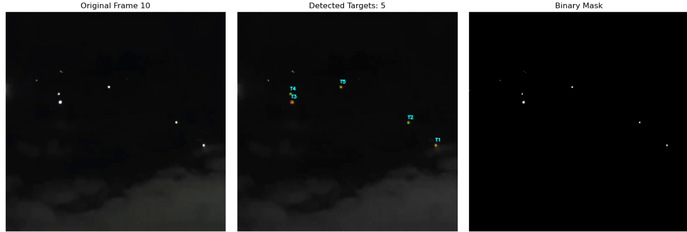

**Chapter 5**

**Conclusion and Future Work**

**5.1 Conclusion**

This project addressed the challenge of detecting low-SNR single-pixel infrared targets by applying a point-spread character–based approach. The proposed methodology integrated three critical modules: filtering, enhancement, and segmentation. The target-protecting filter played a key role in suppressing noise while preserving faint targets, avoiding the loss of weak signals that often occurs with traditional filtering. The enhancement stage, which utilized point-spread local contrast and high-boost filtering, further strengthened the contrast between the target and its surrounding background, making small and dim targets clearly distinguishable.

The adaptive segmentation module added robustness by automatically adjusting thresholds according to the noise conditions of each frame, eliminating the need for manual parameter tuning. Experimental results demonstrated that the method achieved a high detection probability while significantly reducing false alarms compared with conventional techniques. Overall, the study highlights that point-spread character analysis is an efficient and practical solution for infrared surveillance and defence applications.

**References**

[1] Nan, L., Wang, X., Chen, H., & Liu, C. (2019). *Point spread character based low SNR single pixel infrared target detection*. The Journal of Engineering, 2019(20), 7042–7046. doi: 10.1049/joe.2019.0323

[2] Dai, Y., Wu, Y., Zhou, F., & Barnard, K. (2021). *A Low Signal-to-Noise Ratio Infrared Small-Target Detection Network*. IEEE Transactions on Geoscience and Remote Sensing, 59(11), 9513–9525. doi: 10.1109/TGRS.2020.3038573

[3] Gao, C., Meng, D., Yang, Y., Wang, Y., Zhou, X., & Hauptmann, A. G. (2013). *An Infrared Small Target Detection Algorithm Based on Peak Aggregation and Gaussian Discrimination*. Infrared Physics & Technology, 61, 78–88. doi: 10.1016/j.infrared.2013.08.003